Contents

About The Project 2

Dependencies 2

Architecture 2

Getting Started 2

Prerequisites 2

Reactjs Frontend 3

Installation 3

Installation with docker: 3

Nodejs backend 3

Installation 3

Using docker-compose: 4

Usage 4

Credentials for logging in 4

Application Screenshots 5

Testing Screen Shot 6

Request/ Response 7

**Contributing** 8

## About The Project

Build an incident management service should have the following features:

* Raise an incident as an admin
* Assign the incident to a user
* Acknowledge the incident as a user
* Resolve the incident as a user
* Read details about a certain incident
* Index incidents (includes filtering, sorting by date created/updated and incident type and paging)
* Delete an incident

## Dependencies

* Reactjs- Redux
* nodejs
* mongodb [Note : This is running in cluster mode under xxxx]

## Architecture

## Getting Started

### Prerequisites

This is an example of how to list things you need to use the software and how to install them.

Node: npm install node@latest -g or download LTS version from node site

## Reactjs Frontend

### Installation

Clone the repo

git clone <https://github.com/Poonam1910/Ticket-Management-System.git>

Install NPM packages

npm install

Build the project:

npm run build

Run the cypress test:

npm test

Run the project:

npm start

### Installation with docker:

Clone the repo:

git clone <https://github.com/Poonam1910/Ticket-Management-System.git>

Build the docker image:

docker build -t <image_name>/<image_tag> -f Dockerfile.prod .

Run the docker image:

docker run --name <container_name> -p 80:80 -d <image_name>/<image_tag>

## Nodejs backend

### Installation

Clone the repo

git clone <https://github.com/Poonam1910/Ticket-Management-Server-API.git>

Install NPM packages

npm install

Build the project:

npm run build

Run the jest test:

npm test

Run the project:

npm run app

Installation with docker:

Clone the repo:

git clone <https://github.com/Poonam1910/Ticket-Management-Server-API.git>

Build the docker image:

docker build -t <image_name>/<image_tag> -f Dockerfile.prod .

Run the docker image:

docker run --name <container_name> -p 8082:8082 -d <image_name>/<image_tag>

### Using docker-compose:

Start the frontend and backend services:

docker-compose -f <docker-compose.yml> up -d

Stop the frontend and backend services:

docker-compose -f < docker-compose.yml> down

## Usage

### Credentials for logging in

|  |  |  |
| --- | --- | --- |
| UserType | Username | Password |
| Admin | Admin | admin |
| User | User | user |

## Application Screenshots

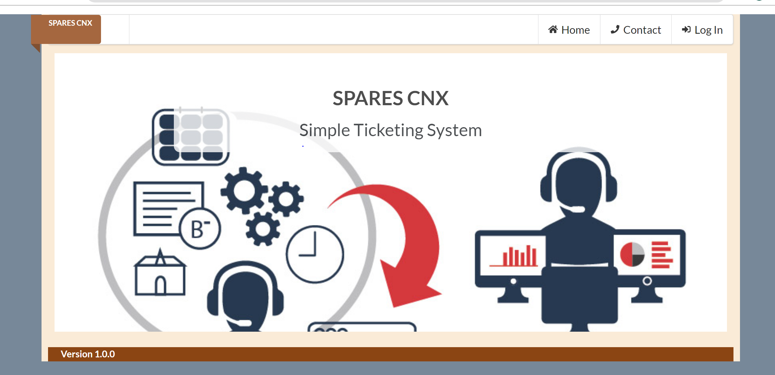

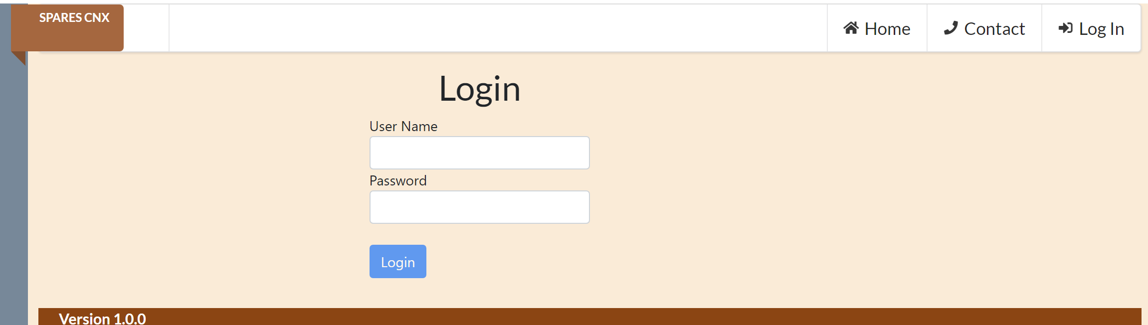

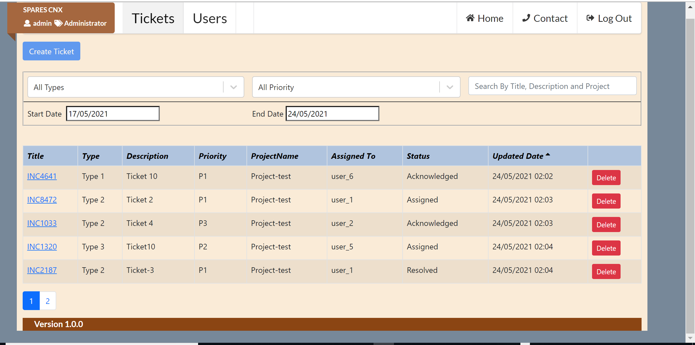

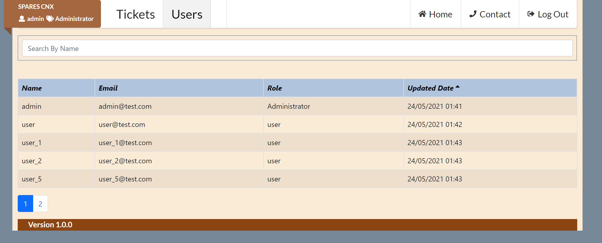

## Testing Screen Shot

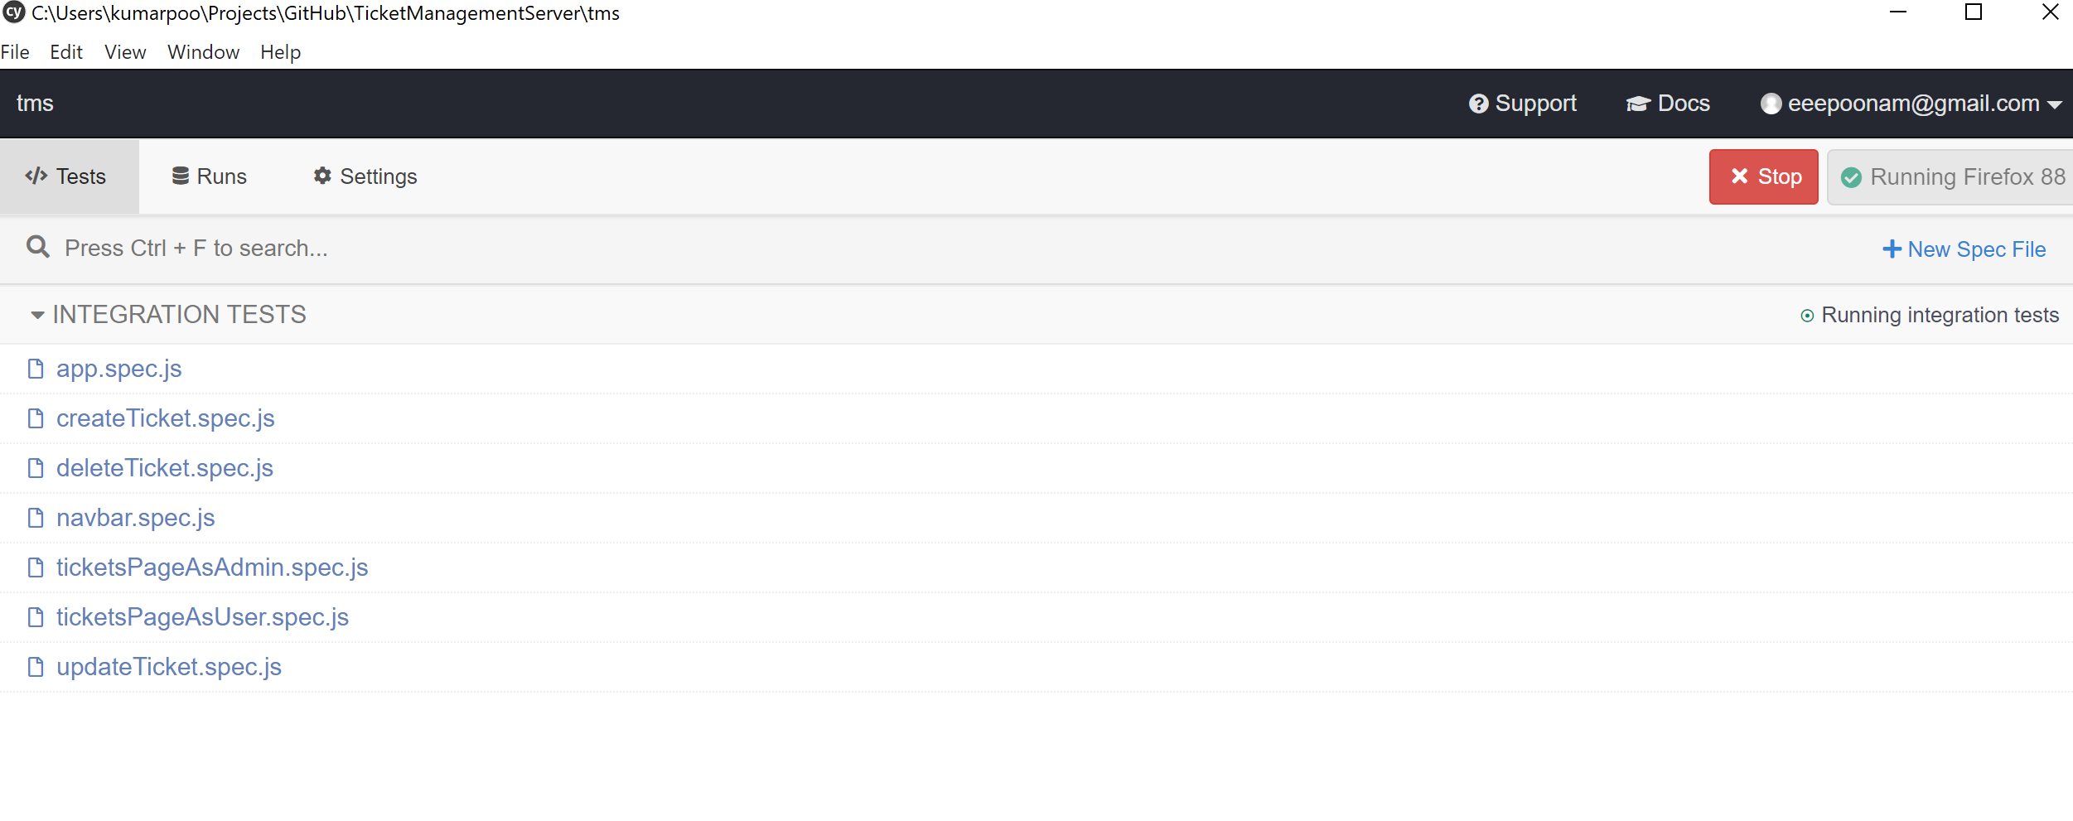

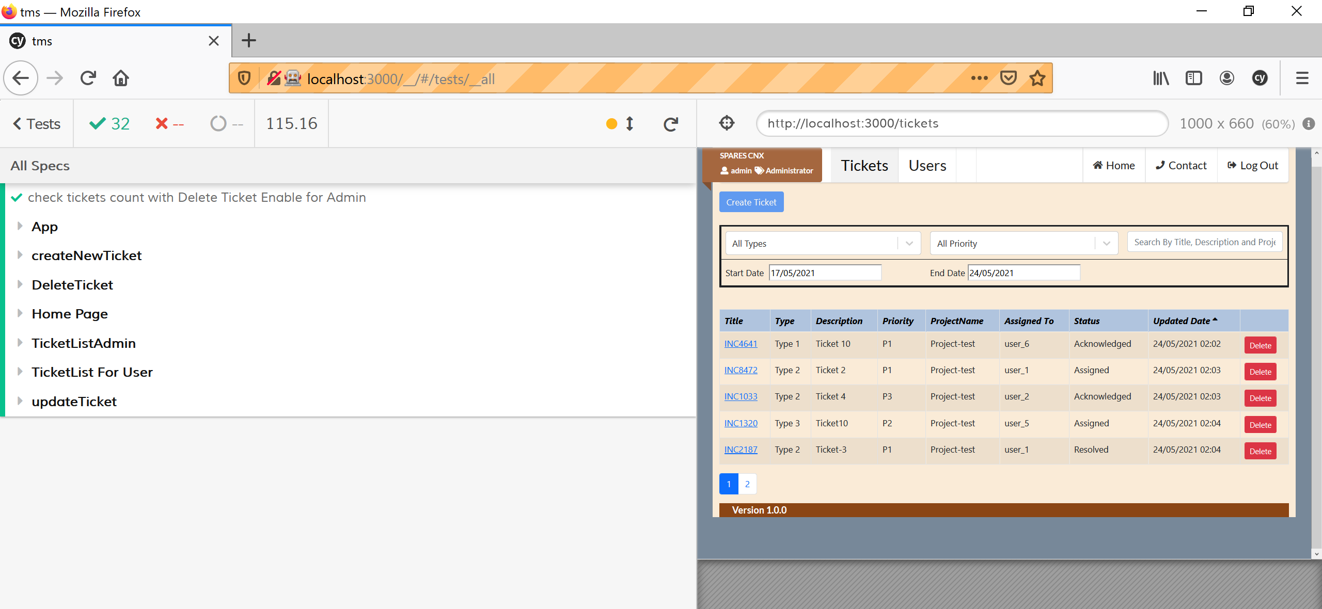

## Request/ Response

CRUD operation is available for Tickets through UI , Similar can be replicated for User.

USER/TICKET CRUD API are available in node project.

Sample json request to create new user

Default port exposed for API: 8082 and for UI as 3000.

Please change the port & host based in application config files based on your exposed Ep.

User Create: http://localhost:XXXX/users/create

User

Get: http://localhost:XXXX/users

Post: <http://localhost:XXXX/users/create>

Put: http://localhost:XXXX/users/<Id>

Delete: http://localhost:XXXX/users/XXX

Json:

{

"name":"user_6",

"role":"user",

"email":"user_6@test.com",

"loginName":"user_6"

}

Tickets

Get: http://localhost:XXXX/tickets

Post: <http://localhost:XXXX/tickets/create>

Put: http://localhost:XXXX/tickets/<Id>

Delete: <http://localhost:XXXX/tickets/XXX>

Json:

{"description": "tes", "projectName": "Project-test", "assigneeId": "60a0c8c9eb957939600487a6",

"priorityId": 1, "typeId": 1,"statusId":1}

### **Contributing**

Contributions are what make the open source community such an amazing place to be learn, inspire, and create. Any contributions you make are **greatly appreciated**.

1. Fork the Project
2. Create your Feature Branch (git checkout -b feature/AmazingFeature)
3. Commit your Changes (git commit -m 'Add some AmazingFeature')
4. Push to the Branch (git push origin feature/AmazingFeature)
5. Open a Pull Request